CSE 283: Final

Name: ______________________________________ Section: _____ _____

- Write legibly and use a pencil.
- Ask questions if something is unclear.
- Write down any assumptions you make.
- The exam is printed on both sides of the page.
- Keep your answers concise. Write the minimum that is necessary when explaining.
- During the exam you may have access the Java API at:

http://docs.oracle.com/javase/6/docs/api/

- Consider the network diagram shown in the supplemental handout. The diagram depicts the following:

- Four end systems labeled A, B, C, and D
- Two switches labeled S1 And S2
(Switch interfaces are labeled 1, 2 and 3 for each switch)
- Five routers labeled R1, R2, R3, R4, and R5.
  - The interfaces of R2 are labeled 1, 2, and 3
  - Router R1 is performing NAT

Information held at various nodes is given in tables on the page attached to the diagram.

Use the diagram and tables to answer the following questions. Write no more than one sentence for “Why or Why not?” questions.

Consider a message being sent from host A to host D and the segments, datagrams, and frames that will be generated to carry the message.
- The socket on A that is being used to send messages has a port number of 5600.
- The port number of the socket being used on D to receive the message is 25.

    - Host D is receiving on port 25, this port is normally associated with the simple mail transfer protocol. Thus, we can assume D is a mail server. What protocol would A use to obtain the IP address of D? (4 points)

    - Would A need the physical address of D? If answer yes, what protocol would A use to obtain the physical address of D? (4 points)

    - Assuming it was not manually set, what protocol would you expect A to use to obtain its own IP address? (4 points)

    - The MAC address of interface card used by D is 49-B7-D2-C7-56-08. How/when is this address normally obtained? (4 points)

    - Based on the information shown to be held by A, can A put together a frame that will be received by R1? Why or why not? (4 points)

    - Based on the information shown to be held by B, can B put together a frame that will be received by R1? Why or why not? (4 points)

    - If A or B in the previous two questions did not have the information needed to put together a frame that would be received by R1, name and describe the process that they would have to complete to obtain the information. (6 points)

    - Based only upon the information shown to be held by various nodes; when A is sending a datagram to D, will the network interface adapter of B receive the frame that is sent by A to R1? Why or why not? (4 points)

    - Based only upon the information shown to be held by various nodes; after A has sent a datagram to D, would the switch table for S1 be updated? If so what entries would be added to the switch table? (4 points)

    - When A is sending a datagram to D, what will be the source IP address and port number in the datagram /segment as it travels between A and R1? (4 points)

Source IP ____________________________________

Source Port ____________________________________

    - When a datagram travels from A to D, what will the source and destination physical addresses be in the frame that carries it from A to R1? (4 points)

Source MAC: ____________________________________

Destination MAC: ____________________________________

    - When A is sending a datagram to D, what will be the destination IP address and port number in the datagram/segment as it travels between A and R1? (4 points)

Destination IP ____________________________________

Destination Port ____________________________________

    - When a datagram travels from A to D, what will the source and destination physical addresses be in the frame that carries it from R1 to R2? (4 points)

Source MAC: ____________________________________

Destination MAC: ____________________________________

    - When A is sending a datagram to C, what will be the source IP address and port number in the datagram /segment as it travels between R1 and R2? (4 points)

Source IP ____________________________________

Source Port ____________________________________

    - Based on the forwarding table given for R2, when A is sending a packet to D, will it forward the packet to R3 or R4? (4 points)

    - Approximately how many hosts could the subnet identified by the third row in the forwarding table of R2 contain? (4 points)

    - When A is sending a datagram to D, what will be the destination IP address and port number in the datagram /segment as it travels between R5 and D? (4 points)

Destination IP ____________________________________

Destination Port ____________________________________

    - When a datagram travels from A to D, what will the source and destination physical addresses be in the frame that carries it from R5 to D? (4 points)

Source MAC: ____________________________________

Destination MAC: ____________________________________

    - Based on the information shown to be held by R5, can R5 put together a frame that will be received by D? Why/ why not? (4 points)

    - Based only upon the information shown to be held by various nodes; when R5 is sending a frame to D, will the interface adapter of C see the frame? Why/why not?
(4 points)

    - Can R5 transmit a frame to D via S2 while C is transmitting a frame to R5 via S2 without colliding? Why or why not? (4 points)

    - Suppose S2 was a hub instead of a switch. Would R5 be able transmit a frame to D via S2 while C is transmitting a frame to R5 via S2 without colliding? (4 points)

    - After R5 has sent a frame to D, would the switch table for S2 be updated? If so what entries would be added to the switch table? (4 points)

    - Suppose the subnet containing R5 and D has a MTU of 580 bytes. Further suppose the original datagrams sent by A have a length of 2570 bytes. Assuming R5 is using IPv4, what would R5 do with the datagrams sent by A? (4 points)

    - If D sends a reply back to A, what will the source IP address and source port number be in the datagram/segment as it travels between D and R5? (4 points)

Source IP ____________________________________

Source Port ____________________________________

    - If D sends a reply back to A, what will be the destination IP address and port number in the datagram/segment as it travels between R2 and R1? (4 points)

Destination IP ____________________________________

Destination Port ____________________________________

    - If D sends a reply back to A, what will be the destination IP address and port number in the datagram/segment as it travels betweenR1 and A? (4 points)

Destination IP ____________________________________

Destination Port ____________________________________

    - In what way will the IP addresses of C, D, and the R5 adapter with a MAC address of 51-3D-CA-CD-04-0C be related? Why?(5 points)

    - If R2, R3, and the R4 are controlled by different organizations, would you expect them to use the same Inter-AS Routing protocol? Why or why not? (6 points)

    - How will the MAC addresses of C, D, and the R5 adapter with a MAC address of 51-3D-CA-CD-04-0C be related? Why?(4 points)

- Consider the following transport and network layer protocols. Place Xs in the following table to indicate what mechanism each protocol uses to deal with various types of transmission errors. If a mechanism is not applicable to the protocol or is not applicable to the problem leave the cell blank. Assume numerous pipelined segments transmitted one after another.(24 points)

 |  | Problem
Protocol | Mechanism | Lost Packets | Duplicate  Packets | Corrupt Packets | Out of Order Packets
UDP | Sequence Numbers
UDP | Timers
UDP | Checksums
TCP | Sequence Numbers
TCP | Timers
TCP | Checksums
IP (v4) | Sequence Numbers
IP (v4) | Timers
IP (v4) | Checksums

- List the five protocol layers of the Internet in order from highest to lowest. (10 points)

_______________________,

_______________________,

_______________________,

_______________________,

_______________________,

- Give definitions for the following terms using one or two sentences. If the term is an acronym, also state what the letters in the acronym stand for. Use no more than two sentences to describe the term.

a. CSMA (6 points):

b. Star topology (6 points):

c. Intra-AS Routing Protocol (6 points):

d. RFC (6 points)

e. Proxy Server (6 points)

- Using node D in Figure 2 as the source, use the link state (LS) algorithm to find the shortest path to all other nodes. Show the members of N, the predecessor of each destination, and the shortest known distance to each destination after the initialization phase of the algorithm and after each loop iteration. (21 points)
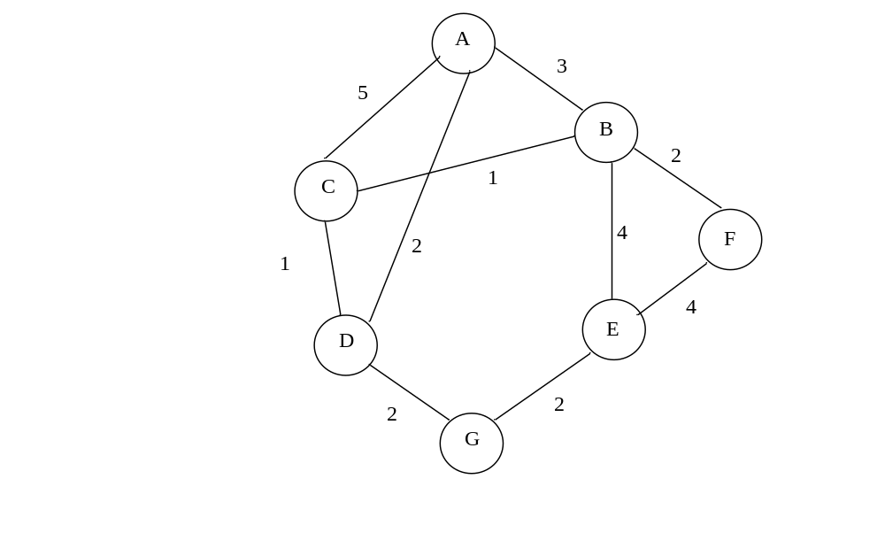
Figure 2: Network Graph

- Consider the following scenario:

An application running on smtp.cnn.com needs to determine the IP address of mail.whitehouse.gov in order to make a TCP connection. In the following, assume that all nodes cache DNS records and that all DNS caches at present only contain the minimum information necessary to function following initialization. DNS server names are as follows:

Top Level Domain DNS server, gov: dns.tld.gov
Top Level Domain DNS server, com: dns.tld.com
Local Name server, whitehouse.gov: local.whitehouse.gov
Local Name server, cnn.com: local.cnn.com
Authoritative DNS, cnn.com: adns.cnn.com
Authoritative DNS, whitehouse.gov: adns.whitehouse.gov
Root DNS server: dns.root

Draw arrows labeled with numbers to indicate the order of queries and responses sent before smtp.cnn.com receives the IP address of mail.whitehouse.gov. The first query sent by smtp.cnn.com is handled recursively. Assume all other queries are handled recursively as well. (24 points)

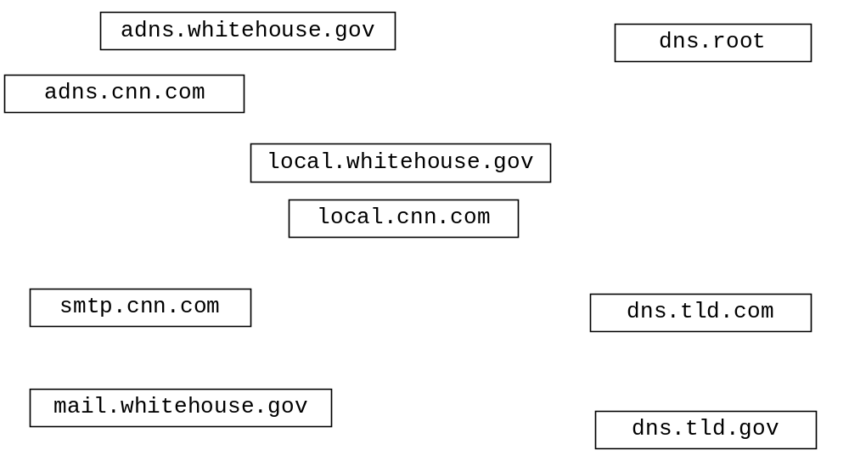
- In a method called run, a server repeatedly receives update messages via UDP. The update messages have the following format:

IP1 (byte) | IP2 (byte) | IP3 (byte) | IP4 (byte) | Port Number (int) | X position (int) | Y position (int) | Heading (int)

Each time it receives an update, the run method does the following:

- Extracts all the information from the datagram.
- Uses the IP bytes and the port number int to construct an InetSocketAddress object which identifies the client that sent the datagram.
- Calls the following method through a class data member called sector to update a database that it maintains using the information contained in the datagram:

void update( InetSocketAddress id, int x, int y, int heading ){…

- Forwards the datagram to an IP address and port number contained in a data member called otherClientAddress.

Updating and forwarding will only end when a boolean data member called listening is equal to false.

Complete the run method on the following page so that it has the functionality described above. Declare local variables as necessary to complete the task. Assume the try block which begins at the beginning of the method will catch all exceptions.(50 points)

public class Server extends Thread{

protected DatagramSocket serverSocket;

protected InetSocketAddress otherClientAddress;

protected boolean listening = true;

protected Sector sector = new Sector();

public Server() throws IOException{

serverSocket = new DatagramSocket( Constants.SERVER_PORT );

start();

}

…

public void run(){

try {

